

|  |  |
| --- | --- |
| **Assignment** | |
| **Course Code** | **CSC402A** |
| **Course Name** | **Web Architecture and Application development** |
| **Programme** | **B.Tech** |
| **Department** | **Computer Science and Engineering** |
| **Faculty** | **Engineering and Technology** |

|  |  |
| --- | --- |
| **Name of the Student** | **Deepak R** |
| **Reg. No.** | **18ETCS002041** |
| **Semester/Year** | **6th/2021** |
| **Course Leader(s)** | **Mr. Kishore S. M.** |

|  |  |  |  |  |  |  |  |  |
| --- | --- | --- | --- | --- | --- | --- | --- | --- |
| Declaration Sheet | | | | | | | | |
| Student Name | Deepak R | | | | | | | |
| Reg. No | 18ETCS002041 | | | | | | | |
| Programme | B.Tech | | | | | Semester/Year | 6th/2021 | |
| Course Code | CSC402A | | | | | | | |
| Course Title | Web Architecture and Application development | | | | | | | |
| Course Date |  | | to |  | | | | |
| Course Leader | Mr. Kishore S. M. | | | | | | | |
| Declaration  The assignment submitted herewith is a result of my own investigations and that I have conformed to the guidelines against plagiarism as laid out in the Student Handbook. All sections of the text and results, which have been obtained from other sources, are fully referenced. I understand that cheating and plagiarism constitute a breach of University regulations and will be dealt with accordingly. | | | | | | | | |
| Signature of the Student | |  | | | | | Date |  |
| Submission date stamp  (by Examination & Assessment Section) | |  | | | | | | |
| Signature of the Course Leader and date | | | | | Signature of the Reviewer and date | | | |
|  | | | | |  | | | |

|  |  |  |  |
| --- | --- | --- | --- |
| Ramaiah University of Applied Sciences | | | |
| Department | Computer Science and Engineering | Programme | B. Tech |
| Semester/Batch | 06/2018 | | |
| Course Code | CSC402A | Course Title | Web Architecture and Application development |
| Course Leader | Mr. Kishore S. M. | | |

|  |  |  |  |  |  |  |  |  |  |  |  |  |
| --- | --- | --- | --- | --- | --- | --- | --- | --- | --- | --- | --- | --- |
| Assignment | | | | | | | | | | | | |
| Register No. | | | 18ETCS002041 | | | Name of the Student | | | DEEPAK R | | | |
| Sections |  | Marking Scheme | | | | | | Marks | | | | |
| Max  Marks | | | First Examiner Marks | Moderator |
| Part 1 |  | | | | | | | | | | | |
| 1.1 | Functional and non-functional requirements | | | | | | 5 | | |  |  |
| 1.2 | Identification and design of the entity classes using E-R diagrams | | | | | | 5 | | |  |  |
| 1.3 | Design of UML interaction sequence diagrams | | | | | | 8 | | |  |  |
| 1.4 | Design of Algorithm/ Flowchart | | | | | | 7 | | |  |  |
|  | Part- 1 Max Marks | | | | | | 25 | | |  |  |
|  | | | | | | | | | | | | |
| Course Marks Tabulation | | | | | | | | | | | | | |
| Component- CET B Assignment | | | | First Examiner | Remarks | | Second Examiner | | | Remarks | | | |
| 1 | | | |  |  | |  | | |  | | | |
| 2 | | | |  |  | |  | | |  | | | |
| Total Marks | | | |  |  | |  | | |  | | | |
| Signature of First Examiner Signature of Second Examiner | | | | | | | | | | | | | |

**Preamble:**

The course on web architecture and application development is aimed at preparing the students to design, develop and test web applications by applying different programming techniques. The students are taught the overview of software architecture and architectural styles. They apply different web technologies to design and develop web applications. They also analyze different software architectures, their benefits and shortcomings. This assignment assesses how well a student can analyze the scenario, design a well-defined user interface for the web application and implement the same. The first part of the assignment is aimed at assessing the student’s ability to design a web application. The second part of the assignment is aimed at assessing the student’s ability to implement an efficient web application.

**Scenario:**  (25 Marks)

In an online Smartphone shopping Web application, users can register and login to the web application. The online smartphone application maintains account details for each user (user ID, user name, phone number, shipping address and items purchased etc.). The user may select any item from the list of available smartphones or can search for all the available smartphones. It is assumed that an item purchased is reserved and made available to the user offline.

**Answer the following questions:**

1. (25 Marks)

List all the functional and non-functional requirements for the given scenario. Identify and design entity classes using E-R diagrams and UML sequence diagrams. Document the following in the report:

* 1. Functional and non-functional requirements
  2. Identification and design of the entity classes using E-R diagrams
  3. Design of UML interaction sequence diagrams
  4. Design of Algorithm/ Flowchart

**Solution 1.1 for Functional and non-functional requirements**

**Functional Requirements**

1. The system must allow authentication for users, with sign in and sign out options, with anonymous login as well
2. The system must allow the users to change their personal details on user details page
3. The system must display the list of the Smartphone products
4. The system must display the highlighted smartphone products on the home screen, linked with the corresponding product detail page
5. The system must allow the user to add smartphone products to a dedicated card of the user
6. The system should allow the user to change smartphone product quantity in the cart and calculate the total amount on the fly
7. The system must have an option to check out the cart and create an order given address, shipping method and payment data with validation
8. The system should present the user with various payment and shipping methods available
9. The system must have a coupon option to be provided at checkout for discounts
10. The system must allow the user to track a created order
11. The system must allow the user to cancel or return an existing valid order
12. The system must allow the user to give rating to a smartphone product
13. The system must allow CRUD (Create, Read, Update, Delete) operations on the smartphone products for the admin
14. The system must allow merchant to add features smartphone products in the home page of the app

**Non-Functional Requirements**

1. The interface of the system should be clean, simple and easy to use
2. The system must be secure and compliant with PCI-DSS for payment processing
3. The system should have an intuitive UI/UX
4. The system must have proper SEO optimization
5. The system must be fast and responsive

## Solution for 1.2 Identification and design of the entity classes using ER diagrams

**The identified entities were**

1. **User**

This is the entity which signs in and signs out of the app, we use this to identify the kind of user (admin/normal user) from the roles attribute, some basic details like firstName, lastName, password, and email are attributes of this entity.

1. **Smartphone Product**

This entity encapsulates the property of an actual Smartphone product that is kept for sale . Details like name, description, price, rating, are some of its attributes.

1. **Rating**

This is a helper weak entity that represents the rating of a product kept for sale, this helps the user sort the products based on their rating and choose wisely the Smartphone product the user wants to buy.

1. **Order**

The order entity keeps track of the items added in the cart, its total price, the customer details, paymentMethod and a unique order number.

1. **CartItem**

This is another weak entity which just stores the product and the amount, the CartItem is a part of the order, and is used to calculate the total price of the cart.

1. **Customer**

Since we are also supporting authentication-less purchases, this Customer attributes is attached to every Order, which is basically the customer shipping details like address, phone, name, email. So, if we have a user, then some of the attribute details are directly taken from there, else details are prompted to be filled.

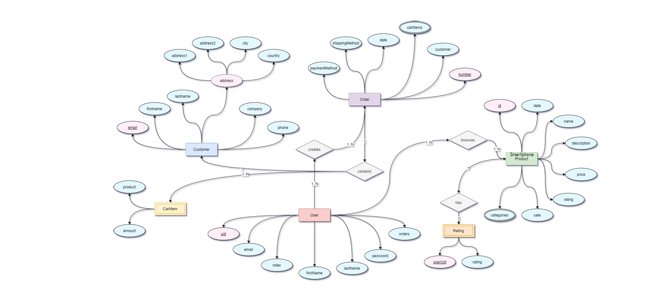

**Solution for 1.3 Design of UML interaction sequence diagrams**

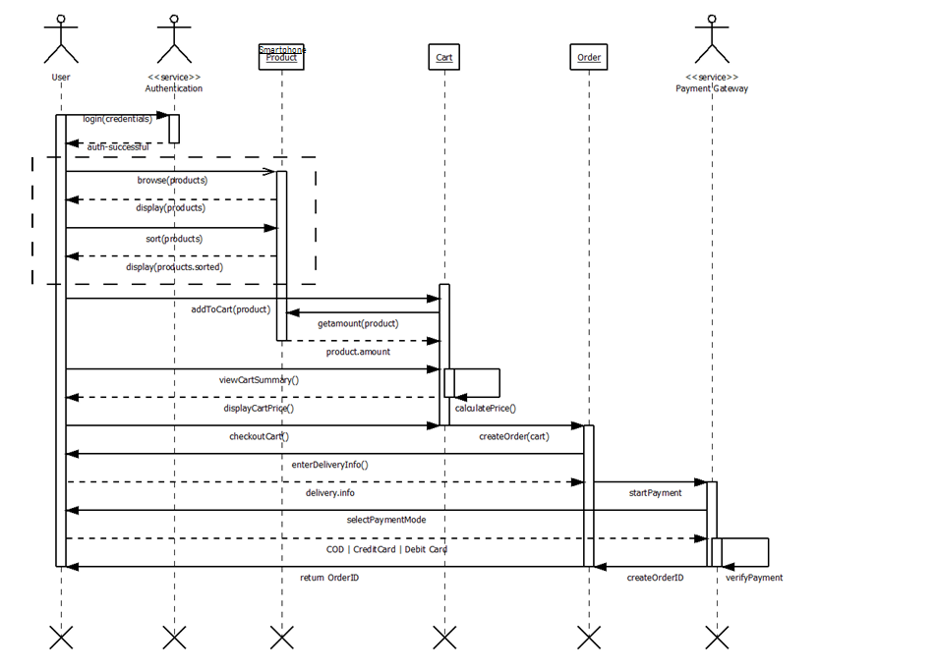

**Solution for 1.4 Design of Algorithm/ Flowchart**

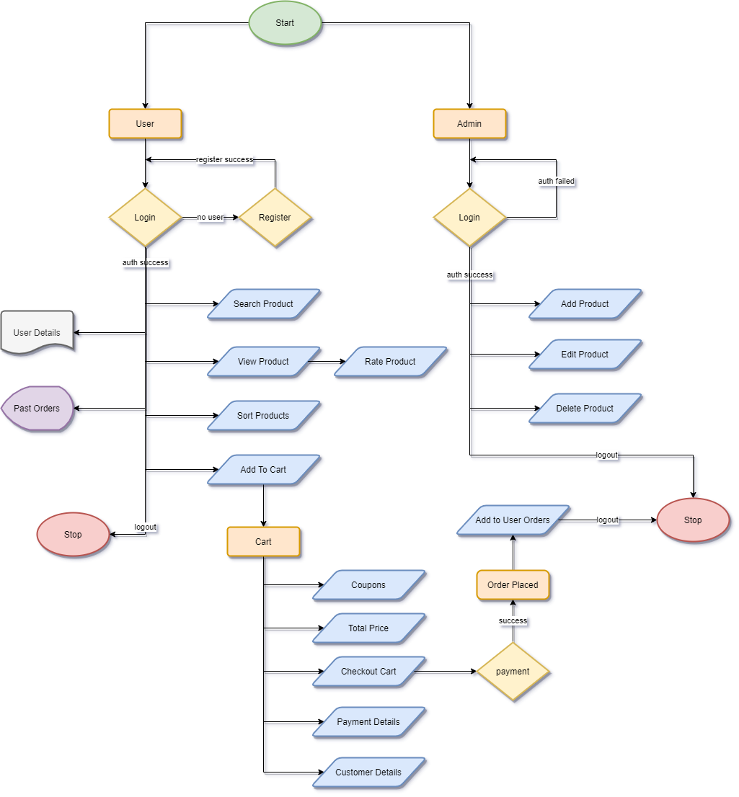

*Read product as Smartphone Products(only in this Flowchart diagram)

### Feature Set

**Smartphone Products**

* Smartphone Products can be sorted based on their price, name and date created
* Smartphone Products can be viewed by the user in a grid/list view
* Smartphone Products are shown in pages, via Pagination

**Cart**

* Smartphone Products can be added to the cart
* Cart is handled by a CartService
* Cart can be cleared at once
* Subtotal and Total is calculated on the fly
* Quantity of each of the item in cart can be adjusted
* Adding the same product multiple times just increments the exiting cart item’s quantity
* Cart has a dedicated page and also a mini cart at the top-right of the website

**Checkout**

* If the user is already authenticated then the Customer details is prefilled
* Address, Shipping method and Payment Data validation
* Anonymous user can also create orders
* Order summary is created once order is done

**Authentication**

* Role based authentication (user/merchant/admin)
* Login using existing account
* Order history
* User details are updatable

# Bibliography

1.Class Notes and Web Architecture lab.